

Aqua Library
Statement of Work

Last Saved: 2015-02-25
Commercial in Confidence

File Name:
Version: | 1.0
Document Reference:
Author: | Kaity Yu
Contact Details:

This work may contain proprietary and confidential information of XOR Media for its internal purposes. Use and disclosure for other purposes, without express written authorization from XOR Media, is prohibited.

© Copyright XOR Media 2015
Content
1 Document Administration 3
1.1 Revision History 3
2 Background & Problems 3
2.1 现有CDN Library方案 3
2.2 Aqua CDN方案 4
3 Requirement 4
3.1 001 内容注入 5
3.2 002点流 5
3.3 003 Density的要求 6
4 Engineering Statement of Work 6
4.1 Overall 6
4.2 HttpCRG w/ CRM_A3 7
4.2.1 A3 Messaging 7
4.2.2 Metadata of A3 Content and .meta Temporary File 9
4.2.3 Lifecycle/State of A3 Content 10
4.2.4 Fault Tolerance 10
4.3 StreamSegmentor 11
4.3.1 AquaClient 11
4.3.2 Content Metadata and State 11
4.4 Stage II - CPE over Aqua 11
4.4.1 CPE 12
4.4.2 CRM_A3 12
5 Work Plan 12
5.1 Milestones 12
5.1.1 CRM_A3 covers the metadata extension 12
5.1.2 CRM_A3 drives CPE session over FUSE 12
5.1.3 StreamSegmenter read content from Aqua 12
5.1.4 Stage I Integration 13
5.1.5 CPE over AquaClient 13
6 QA Assessment 13
6.1 Test Cases Affected 13
6.2 Resources 13

Document Administration

Revision History
Name | Date | Reason For Changes | Version
Kaity Yu | 2015-02-25 | Creation | 0.1
Kaity Yu | 2015-03-11 | Change name to Aqua Library  根据03-10日讨论补充了001, 002中的需求讨论 | 1.0
Andy Shao | 2015-03-24 | Initial draft of tech solution | 2.0
Andy Shao | 2015-03-31 | Removed hash folder,  added stage II CPE over Aqua,  work plan and milestones | 2.1

Customer Name:
Project Name: Aqua Library
Date of Submission: 2015-02-25

Background & Problems

现有CDN Library方案
CDN Library的组成
- 一对SCS
- 若干UML-T

现有CDN Library的问题
- 所有的C2 Locate通过SCS pair上的HttpCRG完成, 无法实现集群式的扩展
- 一台UML-t的性能一直没有能够突破2500 C2 session (历史上曾经测到过3000), 因素可能是多方面的, 但是performance tuning的预期不乐观
- UML-t目前使用SHAS 8+2方案的RAID6, 再通过多台UML-t上的多份replica保证数据的安全, 在最近发布的SCS中增加了对于volume group的支持, 可以指定在多个volume上保留N个副本. 大大简化了对于多volume的支持, 但是当asset/element/replica数量不断增加的情况下, TVBS LAM的性能问题又可能会暴露.

Aqua CDN方案
Aqua CDN的组成
- 若干UML-N (N12, N36)
安装CloudAqua的软件
安装 Aqua Libary的软件
- 若干FMSi
安装Aqua Edge的软件
Aqua CDN必须同时使用Library+Edge才可以工作.
Aqua Edge可以和第三方的Library工作, 比如Cisco CDN Library (Vault+Cache)

Aqua CDN可以解决的问题
- Aqua CDN由Library+Edge组成, 利用Edge来实现客户端限速的功能, 利用Edge和各种客户端集成(C2 Video Server, UDP Pump, IP STB), 利用Edge来实现segmenter切片的功能, 而Library端可以尽量作为一个比较标准的云存储, 使用标准CloudAqua的CDMI的接口, 标准Http的功能. Aqua CDN在Library和Edge之间不再使用NGOD C2.
- Aqua Library按集群式工作, I/O的性能可以随着storage的扩展而同步线性扩展.
- Aqua Library采用CloudAqua+UML-N作为存储方案, 利用云存储方案在低规格的存储设备上解决大数据量的存储和数据安全的问题. 而且可以充分发挥CloudAqua的多种功能: 比如异构存储, 异地备份, 跨地域存储, 自动迁移/备份policy等等. 为今后CDN功能的扩展选择一个最为灵活的平台基础.
- 摆脱对UML-t的依赖, 摆脱对TVBS的依赖, 将CDN的解决方案整体平移到新技术平台上, 更专心打造我们新一代的云技术.

Requirement
ID | Detail Change Description | Priority (1=highest, 3=lowest)
001 | 内容注入: Aqua Library: A3+CPE+CloudAqua内容注入 | P1
002 | 点流: Aqua Library和Aqua Edge集成, Aqua Edge通过AquaClient使用CDMI从Aqua Library获取数据 | P1
003 | Aqua CDN Density的要求 | P1

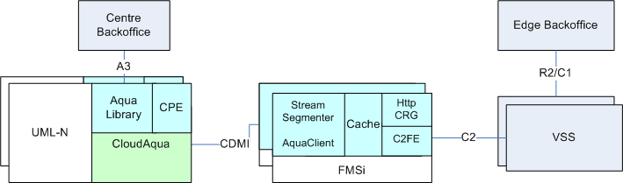

001 内容注入
1, CloudAqua将若干UML-N或者异构的第三方存储组成Cloud Storage. 提供统一的CDMI接口访问
2, Aqua Library的软件负责通过A3和中央Backoffice集成, 接收A3指令, 通过CPE完成不同类型内容的获取, trickgen和上传. 并通过A3汇报状态.
3, 由于假设Aqua Library中的内容会非常多, A3中的Content List功能是否需要可以讨论.
4, A3对外提供服务为了防止单点故障, 可以要求BO进行主备连接设置, 也可以通过HA保护单个A3的接收服务, 在项目初期可能考虑BO进行修改.
5, CPE通过Fuse或者直接调用CDMI创建对象并写入, 可能建议直接利用Fuse, 因为Fuse中不仅完成了CDMI的接口实现, 还包含了failover, redirect, cache, readahead等多个功能.
6, CPE的均衡负载由Aqua Library决定, 原CPC会收集各个CPE当时的工作状态和load, 来负责安排CPE工作. 是否通过HA的方式保护唯一的CPC, 还是利用集群内部数据同步的方式来分享CPE的数据需要在设计中决定.
7, CPE写入数据的storage选择和replica复制由Aqua完成
8, 目前CPE使用UML-t存储数据时, 为了防止一个目录下的文件数量太多, 通过2层hash的目录结构进行数据保存. 当数据存放在Aqua里, 虽然Aqua对于folder并不特别敏感, 但是考虑到今后维护时, 可能需要通过网盘或者fuse进行文件的读取, 如果一个folder下的数据对象有100万或者更多, 网盘和Fuse就会操作困难. 所以可以保留原来CPE的2层hash方式来保持数据对象. Aqua可以通过full path或者是objectID获取数据对象.
9, 考虑到Library中文件的数量会非常大, 所以Library尽量不再使用SQL DB或者Berkley DB, 而直接利用CloudAqua的metadata数据库. 所以在Library的ER结构设计上需要满足A3的要求.

002点流
在Aqua Edge SOW.doc中实现
- FMSi组成Cluster,
- VSS通过HttpCRG进行C2 locate, 通过C2FE获取Chunked Http数据
- 支持segment, 支持本地cache
- 支持PWE

对于Aqua CDN Library
- Aqua CDN的Library和Edge之间直接使用CDMI数据接口, Library不支持NGOD C2.
- 内容在Aqua内部有多副本, 当Aqua Edge请求数据时, CDMI通过Http redirect的方式定向到指定的存储设备
- VSS从Aqua Edge通过C2 Locate获取index, 通过PID+PAID+index的方式构成文件名.
- VSS完成对于index的解析, 获取媒体文件的uuid, 再通过C2 Locate请求数据. 可以考虑在index中的uuid对应Aqua的objectID, 这样Aqua Edge可以直接通过objectID从Aqua Library获取媒体数据.

003 Density的要求

Engineering Statement of Work

Overall
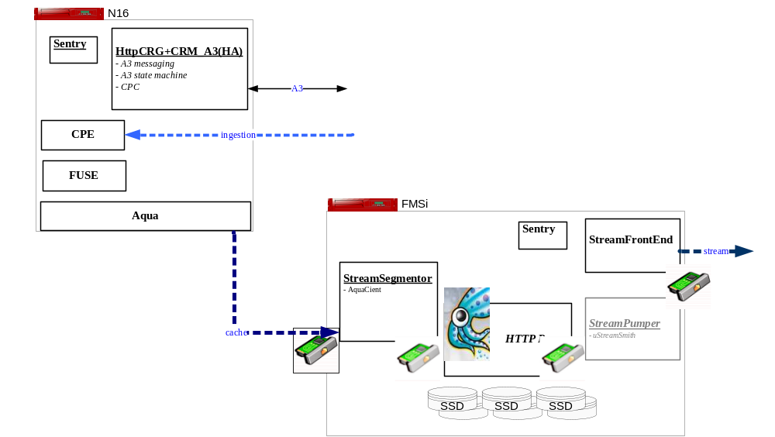
The project covers two major functions:
- Ingestion:
  - HttpCRG with a new plugin CRM_A3 will be deployed on the Aqua node. It covers:
    - A3 messaging includes TransferContent, TransferStatus, GetCotentInfo, DeleteContent, CancelTransfer but excludes GetVolumeInfo, list contents
    - A3 state machine based on metadata or temporary file on Aqua
    - CPC module that provides load balancing of CPE instances
  - CdmiFUSE on Aqua node, it wraps Aqua storage to provide file access for CPE
  - CPE work on the top of CdmiFUSE, it accept the ingestion tasks from CPC module, perform trick generation and save output files thru CdmiFUSE
- Content Delivery:
- The modules deployed on FMSi covers the Content delivery from Aqua Library to the Edge. Continued from the previous project of Linux Streamer, the major gap in this project is the StreamSegmenter adapted with AquaClient, it covers
- read data by taking Aqua client to directly access the data object on Aqua
- determines media content attributes and status by reading A3-oriented metadata or temporary file prepared by the above ingestion procedure

HttpCRG w/ CRM_A3
This component accepts A3 message and drives CPE to perform ingestion

A3 Messaging
TransferContent
When HttpCRG/CRM_A3 accepts a TransferContent request, it
- verifies the request parameters, convert the PID PAID to the content name in the format of PAID_PID
- CRM_A3 verifies if any of the member files of the Content has already existed on Aqua, or reject the request

- Among the collected CPE instances, CRM_A3 pick up a CPE instance to host the ingestion with load balanced thru the internal CPC module
- CRM_A3 update the temporary file with: the endpoint to the CPE session, time stamps about the ingestions
- CRM_A3 appends the content name into its file of ingestions-in-progress
- HttpCRG/CRM_A3 responses the TransferContent request

GetTransferStatus and TransferStatus
When HttpCRG/CRM_A3 accepts a GetTransferStatus request, or it is about to advertise a TransferStatus up to ingestion progress or timer, it
- reads the temporary file of the ingestion to get the endpoint to the ingestion session
- queries the ingestion session on CPE for the progress
- queries Aqua DataObject for file attributes
- then compose the TransferStatus response and send back

CancelTransfer
When HttpCRG/CRM_A3 accepts a CancelTransfer request, it
- reads the temporary file of the ingestion to get the endpoint to the ingestion session
- cancel the ingestion session on the CPE
- clean up all the member files of the content on Aqua

ExposeContent
TBD
low priority

GetContentChecksum
When HttpCRG/CRM_A3 accepts a GetContentChecksum request, it
- reads the metadata of the main file data object with no file extension names, if no metadata[md5checksum] exists, it responses "404 Content file invalid", otherwise
- compose the successful response with md5checksum and md5DateTime

GetContentInfo
When HttpCRG/CRM_A3 accepts a GetContentInfo request, it
- rejects the query with no PID PAID specified, which is known as to list the contents
- reads the metadata of the main file data object with no file extension names, if not available, then tries to read the temporary file of the ingestion
- If the metadata of the main file data object are available, the content would be consider as InService, otherwise as ingestion-in-progress

DeleteContent
When HttpCRG/CRM_A3 accepts a DeleteContent request, it
- reads the metadata of the main file data object, if not available, tries to read the temporary file of the ingestion. In such a way, the CRM_A3 should know all the member files of the content
- If the content is being ingested, CRM_A3 call CPE to cancel the ingestion session
- CRM_A3 call Aqua to delete the content

GetVolumeInfo
Not supported

Metadata of A3 Content and .meta Temporary File
Meta Data | Required in | Data Type | Description
providerID | Metadata-of-completed,  Temp file | string | ID to uniquely identify the provider. For Real Time Content, the provider is “comcast.com”.
assetID | Metadata-of-completed,  Temp file | string | ID to uniquely identify the asset for this provider.
sourceURL | Metadata-of-completed,  Temp file | string | The url to the source file. The allowable transfer protocol are:  “ftp”, “udp”, “cifs”
responseURL | Temp file
transferBitRate | Metadata-of-completed,  Temp file | string | Maximum bit rate at which the content should be transferred.
ingestionSession | Temp file | string | Endpoint to the ingestion session of CPE
state
memberFiles | Metadata-of-completed,  Temp file | string | List of the extension file names
md5Checksum |  | string
timestampCompleted | Metadata-of-completed | string | The timestamp (in the format of ISO8601) when the ingestion is completed, also known as the md5DateTime when it is asked for
timestampCreated | Metadata-of-completed,  Temp file | string
timestampStarted | Temp file | string
timestampStreamable | Metadata-of-completed,  Temp file | string
encodeBitRate

Lifecycle/State of A3 Content
State | Condition | Leave
Pending | No main file data object exists. In the temp .meta file, only timestampCreated is available but no timestampStarted or later are available | ->Transfer: CPE notified ingestion starts  -> Failed: ScheduleEnd is reached
Transfer | No main file data object exists. In the temp .meta file, only timestampCreated and timestampStarted are available but no timestampStreamable or later are available | ->Complete: CPE notified ingestion stop successfully  ->Failed: CPE notified ingestion failed  -> TransferPlay: ???
Transfer/Play | No main file data object exists. In the temp .meta file, only timestampCreated, timestampStarted and timestampStreamable are available but no timestampCompleted is available | ->Complete: CPE notified ingestion stop successfully  ->Failed: CPE notified ingestion failed
Complete | Main file data object exists including timestampCompleted | n/a
Cancel/Failed | See 'Leave' | These two are violate state, which means once ingestion stops, CRM_A3 will trigger a TransferStatus feedback to the responseURL then follow up the content cleaning up procedure

Fault Tolerance
Ingestion starts when HttpCRG/CRM is down
When a provision session was scheduled at a later time, it is possible that the session starts when HttpCRG/CRM_A3 is down, so that the Content in CRM_A3 misses the notification of session-start. In such a case, when CRM_A3 starts, it should cover:
- restore the sessions from the file of ingestions-in-progress,
- ping the provision session on CPE, goes to next "Ingestion when HttpCRG/CRM is down" if the session does not exist.
- Otherwise, read the session status if the session is alive and update the local in-memory state. Especially determine the in-memory status

Ingestion stops when HttpCRG/CRM is down
When a provision session stops during CRM_A3 is down, CRM_A3 would not successfully ping the CPE session during restore, so that CRM_A3 should:
- read the metadata of main file in Aqua, if failed, read the .meta temporary file instead, consider the provision as failure if neither can be read
- Consider the provision as failure if the metadata "FailReason" exists, issue a TransferStatus feedback to the responseURL then clean up the context of the Content
- Otherwise, consider the provision has been succeeded and populate the attributes and issue a TransferStatus feedback

HttpCRG/CRM fails over/back
The CRM covers fail-over/back by covering the above two cases

CPE restarts
The CRM covers fail-over/back by covering the above two cases

Failed to connect to Aqua
For contents in the state of Transfer and/or Transfer/Play, CRM may response directly via its in-memory context when it fails to read from Aqua
For the contents in other states that can not be read from Aqua, CRM response 503 Service Unavailable

StreamSegmentor
Continued from the project of Linux Streamer, the StreamSegmentor covers the following gaps in this project:

AquaClient
- Instead of C2Client in the previous project, StreamSegmentor will invoke AquaClient to input the required content from the storage of Aqua under a configured home container
- In the first stage, as the AquaClient appears as a sync-client API, the scheduler of StreamSegmentor would be enhanced to fit such a situation

Content Metadata and State

- For PID PAID of a required content, StreamSegmentor name conversion for the name of content and member files
- For the completed contents on Aqua, StreamSegmentor reads the metadata of the main file data object from Aqua
- In the case that the metadata of main file data object is not available, StreamSegmentor would consider the content may being ingested, so that it would try to read a temporary file with an extension name ".meta" about the attributes

Stage II - CPE over Aqua
In Stage I CPE over FUSE, a critical issue was ignored that the ingestion will save more and more contents under a same folder. Although it may be not a issue for Aqua storage, as mounted like a Linux directory thru FUSE, it is hardly to avoid people or OS from executing directory list, which may lead to a uncontrollable system load.
In stage I, for demo purpose, we assume there are no big amount contents will be ingested. So we temporarily save them all in a same home container.

This stage II is to make CPE to directly save content thru AquaClient, so that the CdmiFUSE will not be involved to avoid the above functional leak.

CPE
Besides the existing NativeFS and Vstream SeaFile impl of CPE FileIO abstraction, a new impl of the abstraction will be developed to save file directly to Aqua storage thru Aqua client.
Additionally, the metadata update of content main-file will also be taken by CPE session only, in order to cover exception case more smoothly.

CRM_A3
All the metadata update of content main-file will also be taken by CPE session only. As a result the CRM_A3 only read those metadata, some write logic made in the Stage I will be cleaned

Work Plan

Milestones

CRM_A3 covers the metadata extension
When this milestone is reached, CRM_A3 has covered A3 messaging, and has integrated AquaClient. Instead of local DB, it defines the .metadata and the metadata on the main-file in Aqua. It exports a common class about metadata access and naming conversion. (Apr. 7)

CRM_A3 drives CPE session over FUSE
When this milestone is reached, CRM_A3 has integrated internal CPC module, and is able to dispatch provision sessions among CPE instances. Also CRM_A3 and CPE covers the exceptions of HttpCRG restart and CPE restart (Apr. 20)

StreamSegmenter read content from Aqua
When this milestone is reached, StreamSegment is able to read the content from Aqua. Additionally, it takes the common definition of metadata and name conversion to read the content status and media attributes from Aqua (Apr. 20)

Stage I Integration
This milestone focus on the integration and initial performance (Apr. 30)
- From A3 to C2 end-to-end full test: Content ingestion thru A3, and is pulled by StreamSegmenter then pumped from C2FE
- Both completed content and PWE contents are tested
- Initial performance tests will be executed

CPE over Aqua
The 2-week timeframe in May after Stage I integration will be focus on:
- CPE over Aqua about ingestions
- Further more performance tuning on streaming

QA Assessment

Test Cases Affected

Resources

